End-User Requirements – EUR-I2302029
  - DBOX ENHANCEMENT
Quick configurator parant and child layout change

Irpinia Kitchens

Document Approval
Approver | Approved Date | Rejected Date | Comments

Part 1: Functionality Overview
- Objectives (Why are we doing this?)
As per Irpinia’s business model, DBOX quick config to be maximum effective when quote is creating by Irpinia’s users or dealers.
  - Change the parent/child configurator layout to show the parent portion as kitchen cabinets comment features and child lines to be the kitchen cabinets devided per 3 categories – Upper, Lower and Tall cabinets.
  - Parent options:
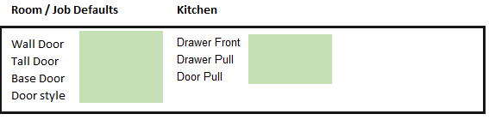

Wall Door and all the option shown above to be drop down options.

  - Child options:
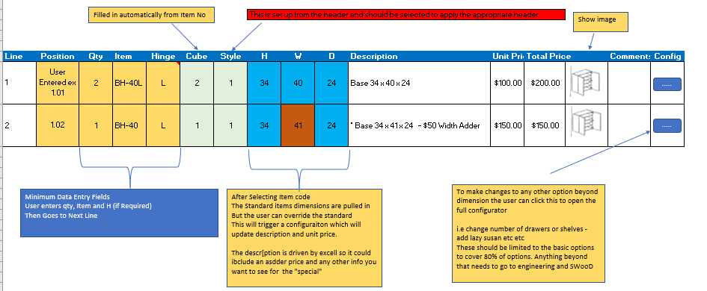

- The user will be able to select the mastered item from the list, example BH-40L. This will automatically field the columns: Item, Hinge, Cube, Stype, H, W, D, unit price, Total price and the image if there is image in the mastered item.
- The field Cube and Style to be pulled from the item master UDF fields.
- The column “ Position” should be empty and editable. The user will add the cabinate position in this field manually.
- The field Hinge to be defaulted to Left and if necessary to be changed manually.
- The fields H, W and D to be editable in case that the user would like to change some of the parametars.
- There should be a button that will allow the user to open the child config properties in order to changes something that is not in the main grid.
2. If there is a custom product that the configurator cannot be used, Irpinia should have a “Custom product” item in the Item master that can be used from their dealers to enter a request for quote/price adding the necessary information for Irpinia to properly quote the Custom order.

- Business Process

- User Roles and Responsibilities
  - Seradex to change the DBOX interface as proposed.
  - Irpinia to create new configurator file to match the proposed DBOX interface configuration.
- Interactions with Other Systems
  - N/A
- Production Rollout Considerations
- Terminology

Part 2: Functional Requirements

Part 4: Change Order Details

Date | Enhancement | Requested By | Notes | Priority | Release Status

Please note that custom reports or searches are not included in the scope of this EUR.

